A Conceptual Design and Economic Assessment of a Chitin Biorefinery Based on Shrimp Processing Wastes
Ana Carolina Moreira Fonseca,^{a*} Bruno Faccini Santoro,^{b} Omar José Guerra Fernández,^{c} Moisés Teles dos Santos,ª
ª Department of Chemical Engineering, Escola Politécnica, Universidade de São Paulo, Av. Prof. Luciano Gualberto, trav. 3, n. 380, São Paulo, 05508-010, Brazil
^{b} OP2B - Soluções para Otimização de Negócios Ltda. Avenida Pompeia, 723, São Paulo, 05023-000, Brazil
^{c} National Renewable Energy Laboratory, 15013 Denver West Parkway
Golden, CO 80401, 303-275-3000
*acmfonseca@usp.br
Abstract
Due to the extensive production of shrimp in captivity, waste generation has increased significantly and has become an environmental problem. The recovery of biomolecules can be an important way to mitigate the environmental problems associated with processing in this sector. In this sense, the present work aimed to evaluate a biorefinery approach for valuing shrimp farming waste to obtain astaxanthin, chitin and chitosan. Stoichiometric segmentation was used as a tool to identify the process steps, whose information on process variables (fresh water consumption, flow rate and reaction conditions) was adapted from the literature. A biorefinery coupled to a shrimp processing plant was proposed for the immediate use of highly perishable biomass, to guarantee the quality of the extracted products and reduce storage and transportation costs. In practice, the biomass treatment sequence adopted (demineralization followed by deproteinization) eliminates the depigmentation step, as the chitin obtained has a lighter tone. The proposed route was evaluated for four scenarios based on two indicators: gross economic potential (EGP) and metrics for inspection of sales and reagents (MISR). The results indicate that economic viability is achieved only for the production of chitosan, resulting in a gross revenue of US$832.50/cycle and a MISR value > 1. The sale of astaxanthin promotes an increase of US$3.73/cycle in the EGP, considered too low for the inclusion of another stage in the process.
Keywords: chitin, chitosan, astaxanthin, biorefinery, shrimp waste.
  - Introduction
Shrimp farming is a kind of aquaculture in which shrimp are raised in a confined and controlled space. The risk of extinction of marine species captured in the wild has stood out as one of the main reasons for the increase in consumption of species cultivated in captivity, in addition to controlling production costs, standardizing products, and consistency in supply (Veríssimo et al., 2021). However, the amount of waste generated is significant, representing 30-60 % of the animal's total weight, and is disposed in landfills or inappropriate locations, causing environmental problems and risks to human health. The recovery of this waste presents itself as a promising alternative since this biomass is a source of bioactive compounds such as astaxanthin, chitin, proteins, and minerals (Aneesh et al., 2020).
Chitin, which makes up about 15-40 % of shrimp shells, is the product of greatest interest. It is the second most abundant biopolymer in nature after cellulose, with similar molecular structures. The chitin extraction process involves three steps: i) depigmentation, ii) demineralization, and iii) deproteinization. Chitosan, obtained from the deacetylation of chitin, is a biopolymer of industrial interest as it has properties such as biodegradability, biocompatibility, low levels of toxicity, and allergenicity, forms gels easily and inhibits growth of microorganisms (Verardi et al., 2023). Despite the potential for application in several areas, chitosan production on a commercial scale is still under investigation. The chemical method is the most commercially used to obtain this biopolymer. However, it results in acidic and alkaline residues that are toxic to the environment and difficult to treat. Furthermore, it requires the consumption of large amounts of water to wash the biomass between the stages, which limits the sustainability of the process on an industrial scale.
Process Systems Engineering (PSE) deals with the development of systematic techniques to identify an optimal topology of processes, raw materials, and products (Bertran et al., 2022). Recent studies have employed simulation tools (Gómez-Ríos et al., 2019), life cycle assessment (Yang et al., 2019), technical, economic, and environmental assessments (TEA) (Zuorro et al., 2021), and exergetic techniques (Muñoz et al., 2023) to estimate the impact of biorefineries based on chitinous biomass. In this sense, the present work aims to develop a conceptual design for a chitin biorefinery based on shrimp farming waste. A preliminary economic analysis was carried out to identify the feasibility of recovering astaxanthin, chitin, and chitosan-based on product sales prices, reagent costs, and effluent treatment costs generated in the process.
  - Methodology
2.1. Process description
Three possible products are considered: astaxanthin, chitin and chitosan. The design was made considering that the plant is installed close to a shrimp processing plant with a batch processing capacity of 1 t/cycle of fresh shrimp, and each section is briefly described.
2.1.1. Shrimp Fishing, Processing and Waste Pre-treatment
Shrimp is removed from the ponds and immersed in tanks with ice and sodium metabisulfite solution (MBS) 9 % (w/w). Damaged and stained shrimp is separated in the sorting unit. The heads and shells are removed in the decapitation and peeling steps, respectively. The main output stream corresponds to shrimp meat. The output streams containing the shrimp heads and shells are washed, dried and ground. The composition of the incoming dry biomass stream in the depigmentation section was considered the experimental characterization of the Penaeus vannamei shrimp shell, as presented in Table 1, with the set of reactions used for stoichiometric segmentation.
Table 1. Average composition of Penaeus vannamei shrimp shells and stoichiometric reactions for processing shrimp farming waste.
Component | Composition (%) | Process Step | Reaction Set
Astaxanthin | 0.41 | Depigmentation
Calcium carbonate | 5.13 | Demineralization | CaCO₃ + 2 HCl→CaCl₂ + H₂O + CO₂
Sodium carbonate | 2.62 |  | Na₂CO3 + 2 HCl→2 NaCl + H₂O + CO₂
Magnesium carbonate | 1.52 |  | MgCO₃ + 2 HCl→MgCl₂ + H₂O + CO₂
Calcium phosphate | 12.90 |  | Ca₃(PO4)₂ + 6 HCl→3 CaCl₂ + 2 H₃PO₄
Total protein | 36.60 | Deproteinization | Dipeptide + 2NaOH→ 2Aminoacid⁻Na⁺ + H₂O
Total fat | 6.40 | Saponification | C₁₇H₃₄O₂ + NaOH→ C₁₆H₃₁0₂Na + CH₃OH
Chitin | 29.97 | Deacetilation | C₈H₁₅NO₆ + NaOH→ C₆H₁₃NO₅ + C₂H₃NaO₂
Moisture | 4.45
2.1.2. Chitin Recovery
Depigmentation is carried out by suspending the material in an 80 % ethanol-water solution (w/w), in a solid-liquid ratio of 1:5. With the material dried and discolored, acid demineralization of inorganic salts is carried out using 5.2 % (w/w) HCl solution, in a solid-liquid ratio of 1:5, at room temperature, under constant agitation for approximately 50 min. Then, the stream is filtered and the demineralized biomass is washed with water until neutral pH is achieved. For the deproteinization step, the chitin-rich stream is separated from proteins using 4 % (w/w) NaOH solution, in a solid-liquid ratio of 1:10. The output stream is filtered and the resulting solid fraction is washed with water until pH neutrality. Then, the product can be sold as a raw material for the synthesis of chitosan. This step also hydrolyzes and removes lipids which can then be separated from the protein. A fraction of fats presented in the raw material was assumed to be methyl palmitate.
2.1.3. Chitosan Recovery
The deacetylation reaction produces chitosan from the hydrolysis of acetamide groups of chitin molecules with 50 % (w/w) NaOH solution, in a ratio of 1:10. The chitosan-rich stream is washed until pH neutral and dried.

2.2. Economic viability
Revenue was the economic metric used to preliminarily assess the viability of the shrimp biorefinery based on four scenarios: 1) chitin recovery; 2) recovery of chitin and astaxanthin; 3) conversion of chitin to chitosan, and 4) conversion of chitin to chitosan and recovery of astaxanthin. The indicators economic gross potential (EGP) and metric for inspecting sales and reactants (MISR) were adapted from El-Halwagi (2017), as described in Eqs. (1) and (2). EGP provides an upper limit for process revenue without considering operational and fixed costs. For the process to be viable, the EGP must be greater than zero. However, positive EGP values do not guarantee the viability of the process. Therefore, MISR is used as an indicator analogous to EGP, with values greater than one being desirable for a more detailed analysis of the approach. Table 2 shows the prices of reagents and products, as well as the costs of treating effluents.
$EGP=\left(\sum_{p=1}^{N_{products}}{Production rate of product p*Selling price of product p}\right)-\left[\left(\sum_{r=1}^{N_{reactants}}{Feed rate of reactant r* Purchase cost of reactant r}\right)+\left(\sum_{e=1}^{N_{efluents}}{Effluent generation rate e*cost for effluent treatment e}\right)\right]$ (1)

$MISR=\frac{\sum_{p=1}^{N_{products}}{Production rate of product p*Selling price of product p} }{\left(\begin{aligned}\sum_{r=1}^{N_{reactants}}{Feed rate of reactant r* Purchase cost of reactant r} + \\ \sum_{e=1}^{N_{efflluents}}{Effluent generation rate e*cost for effluent treatment e} \end{aligned}\right)}$ (2)
Table 2. Prices of feedstock, products, and effluent treatment costs.
Feedstock | Price (Moreno-Sader et al., 2021)
Sodium metabisulfite | $ 0,50/kg
Ethanol | $ 0,85/kg
HCl | $ 0,30/kg
NaOH | $ 0,20/kg
Freshwater (Turton et al., 2018) | $0,26/1000kg
Product | Price (Moreno-Sader et al., 2021)
Astaxanthin | $ 40,00/kg
Chitin | $ 17,00/kg
Chitosan | $ 35,00/kg
Effluents | Costs (Turton et al., 2018)
Wastewater treatment | (filtration+activated sludge+chemical processing): $ 56/1000 m³
  - Results and Discussion
The conceptual design for the shrimp farming waste biorefinery is based on material recycling and reuse flows. The limited data available on industrial-scale crustacean biorefinery justifies the use of the stoichiometric segmentation technique to comprehensively evaluate the chosen routes. Based on the reactions involved in each stage of the process, the input and output flow rates per component were identified, as well as the points where fresh water is used and where effluents are discarded. The flowsheet diagram of the shrimp shell biorefinery is shown in Figure 1.
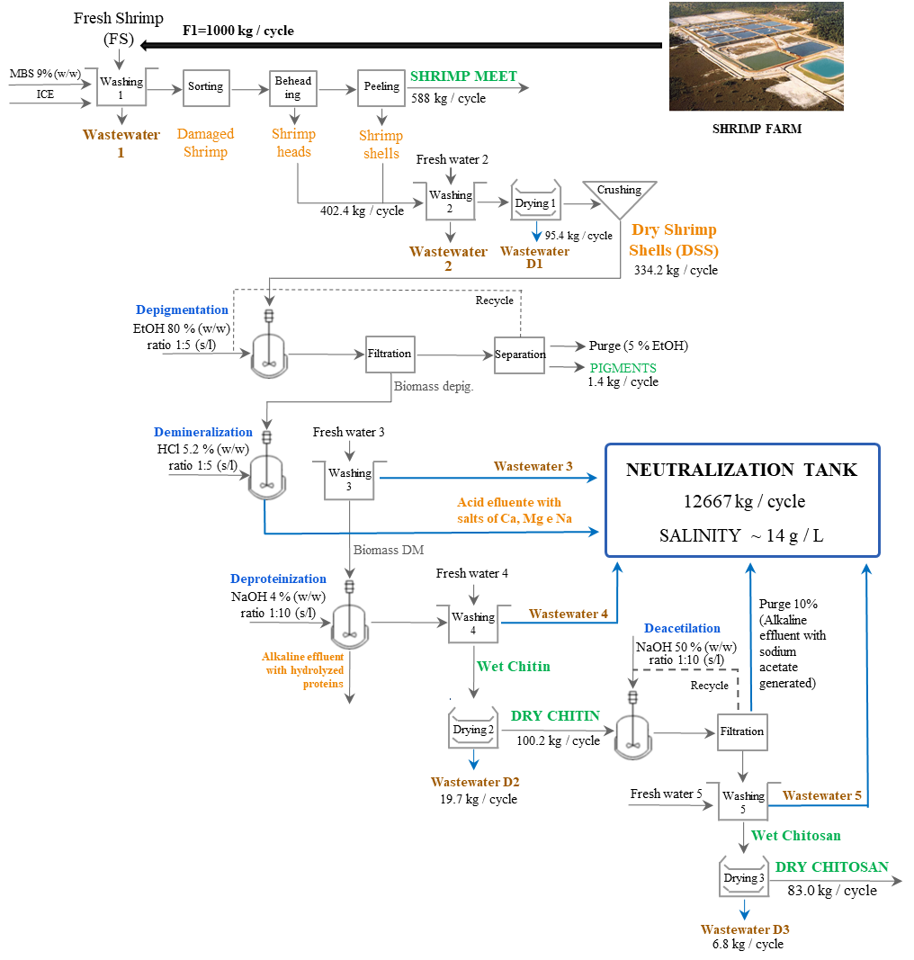
Figure 1. Process flowsheet of a biorefinery for valorizing shrimp farming waste.
In the waste processing stage, peel flour is produced, which has a high nutritional value and can be used as a protein source in animal diets, in addition to containing astaxanthin and chitin, considered the components with the highest added value. This approach considered the recycling strategy in the depigmentation and deacetylation stages to minimize production costs. The ethanol used to extract the pigment is evaporated and the vapor must be condensed and purged by 5 % by mass. The NaOH solution used for chitin deacetylation must be recycled and purged by 10%. Adjusting the concentration of recycled solutions is done by adding fresh reagents according to the purge (Gómez-Ríos et al., 2017). Given the acidic and basic nature of the effluents generated in the process, the streams from washing stages 3, 4, and 5, the effluent generated in the demineralization stage, and the purge of the deacetylation stage are neutralized in a mixing tank to reuse this water for irrigation or shrimp farming in artificial waters (Moura et al., 2023). In the case of integrating wastewater without prior treatment, the output streams from drying stages 1, 2 and 3 would be able to meet the demand for ice in the shrimp fishing process, generating savings of $ 0.03/cycle, representing a value insignificant.
By changing the order of steps and reaction parameters in the pretreatment and conversion of shrimp biomass, chitin and chitosan with variable physicochemical properties can be produced. It is advisable to first extract the pigments to guarantee the integrity of the product. This case study considered the hypothesis that demineralization occurs before deproteinization. This sequence of operations does not require the biomass depigmentation step, as the chitin obtained has a lighter tone when compared to the reverse sequence. In this sense, a preliminary economic analysis was carried out to assess whether it would be worthwhile to include the pigment recovery stage. According to the prices of raw materials, products, and wastewater treatment costs provided by Table 2, the values for EGP and MIRS were estimated for four scenarios, as shown in Table 3.

Table 3. EGP and MIRS indicators before and after water mass integration.
SCENARIO | REVENUE ($/cycle) | COSTS ($/cycle) | EGP ($) | MISR
1) Chitin recovery | 1702,73 | 1731,07 | -28,34 | 0,98
2) Chitin recovery + Astaxanthin | 1765,95 | 1782,15 | -16,20 | 0,99
3) Chitosan recovery | 2906,01 | 2073,51 | 832,50 | 1,40
4) Chitosan recovery + Astaxanthin | 2960,82 | 2124,59 | 836,23 | 1,39

The process did not prove to be economically viable for Scenarios 1 and 2, as shown by the negative EGP values. The revenue obtained from the sale of pigments promoted a slight increase in gross profit ($ 3.73), as indicated by positive values for EGP and greater than 1 for MIRS in scenario 4. However, it is worth highlighting that the recovery of the solvent used to extract the pigments requires high energy consumption, which directly impacts revenue. This study only considered the costs of reagents and, therefore, the proposed approach presents attractive economic potential only for scenario 3.
Decolorization becomes an important step if a highly purified product is required, for example in application as a biomaterial where residual pigments can cause side effects. In this case, high-quality chitosan is more expensive, offsetting the costs of implementing more steps in the process. The price of astaxanthin must be adjusted so that the inclusion of the pigment recovery step is profitable. It is worth noting that the EGP and MIRS values are linked to the sales prices of the products and may undergo changes, requiring a sensitivity analysis. Furthermore, the use of enzymatic and fermentative processes must be considered as they enable the recovery of protein hydrolysates and mineral salts, diversifying the products to be obtained from the shrimp wastes.
  - Conclusions
This work aimed at applying stoichiometric segmentation to determine the performance of shrimp farming waste processing to obtain chitin, chitosan, and astaxanthin by the chemical method without considering detailed project calculations. According to the parameters adopted, the conceptual approach of the biorefinery was viable only for obtaining chitosan (Scenario 3), resulting in a gross revenue of $ 832.50/cycle. The slight increase in revenue obtained from the sale of astaxanthin did not compensate for the inclusion of another step in the process. In this study, economic indicators were considered that provide an upper limit to the process revenue. However, it is important to consider other sustainability assessment tools when making decisions regarding the implementation of large-scale facilities.

Acknowledgements. The authors thank FAPESP agency for the financial support (project number 2022/02809-0 and 2023/07775-0).
References
P. A. Aneesh, R. Anandan, L. R. G. Kumar, K. K. Ajeeshkumar, K. A. Kumar, S. Mathew. 2020. A step to shell biorefinery-Extraction of astaxanthin-rich oil, protein, chitin, and chitosan from shrimp processing waste. Biomass Conversion and Biorefinery, 13, 205-214.
M. Bertran, A. K. Tulac, R. Gan. 2022. Sustainable biorefinery process synthesis, design, and simulation: Systematic computer-aided methods and tools. In: N. Thongchul, A. Kokossis, S. Assabumrungrat, A-Z of Biorefinery, Elsevier, 2022, 559-605.
M. M. El-Halwagi. 2017. Benchmarking Process Performance Through Overall Mass Targeting. In: Sustainable Design through Process Integration, 2nd edition, Elsevier, 73-125.
D. Gómez-Ríos, R. Barrera-Zapata, R. Ríos-Estepa. 2017. Comparison of process technologies for chitosan production from shrimp shell waste: A techno-economic approach using Aspen Plus®. Food and Bioproducts Processing, 103, 49-57.
D. Gómez-Ríos, G. Navarro, P. Monsalve, R. Barrera-Zapata, R. Ríos-Estepa. 2019. Aspen Plus® Simulation Strategies Applied to the Study of Chitin Bioextraction from Shrimp Waste. Food Technology and Biotechnology, 57, 2, 238-248.
K. A. Moreno-Sader, J. D. Martinez-Consuegra, A. D. González-Delgado. 2021. Development of a biorefinery approach for shrimp processing in North-Colombia: Process simulation and sustainability assessment. Environmental Technology and Innovation, 22,1-14.
P. Moura, I. A. Neto, H. Brandão, P. Furtado, L. Poersch, W. Wasielesky Jr. 2023. Effects of magnesium reduction in artificial low-salinity water on the growth of Pacific white shrimp Litopenaeus vannamei in a biofloc system. Aquaculture, 577, 1-9.
F. L. Muñoz, S. Meramo, L. Ricardez-Sandoval, A. D. Gonzalez, B. C. Castillo, A. G. Quiroga, B. L. G. Baptiste, J. León-Pulido. 2023. Insights from an exergy analysis of a green chemistry chitosan biorefinery. Chemical Engineering Research and Design, 194, 666-677.
A. Verardi, P. Sangiorgio, S. Moliterni, S. Errico, A. Spagnoletta, S. Dimatteo. 2023. Advanced technologies for chitin recovery from crustacean waste. Clean Technologies and Recycling, 3, 1, 4-43.
R. Turton, R. Bailie, W. Whiting, J. Shaeiwitz, D. Bhattacharyya. 2018. Analysis, Synthesis, and Design of Chemical Processes, 4th edition, Pearson, 212-213.
N. V. Veríssimo, C. U. Mussagy, A. A. Oshiro, C. M. N. Mendonça, V. C. Santos-Ebinuma, A. P. Júnior, R. P. S. Oliveira, J. F. B. Pereira. 2021. From green to blue economy: Marine biorefineries for a sustainable ocean-based economy. Green Chemistry, 23, 9377-9400.
H. Yang, G. Gözaydın, R. R. Nasaruddin, J. R. G. Har, X. Chen, X. Wang, N. Yan. 2019. Toward the Shell Biorefinery: Processing Crustacean Shell Waste Using Hot Water and Carbonic Acid. ACS Sustainable Chemistry and Engineering, 7, 5, 5532-5542.
A. Zuorro, K. A. Moreno-Sader, A. D. Gonzalez-Delgado. 2021. Evaluating the feasibility of a pilot-scale shrimp biorefinery via techno-economic analysis. Journal of Cleaner Production, 320, 1-11.

